E-Commerce Cart System
Create a Python program to add, remove, and view products in a shopping cart and calculate the total bill sing lists and loops

Subject Name: Python Programming

Subject Code: 1BPLC105B

Submitted By: Submitted To:
Gowtham Gowda C B Ms. Vinutha M
AIT25BEAI141

+

Models.py

from termcolor import colored
from datetime import datetime
from history_json import save_cart
from playsound import playsound
from pathlib import Path

class user:
def __init__(self,name):
if not name.strip():
self.name = "Guest User"
else:
self.name = name.capitalize()

class CartSys:

def __init__(self):
self.cart = []

def add_item(self, item_name, quantity, price):
self.cart.append([item_name, quantity, price])

def total_price(self):
total_sum = sum(item[1] * item[2] for item in self.cart)
return total_sum

def view_cart(self):

print("\n","-"*60,colored("\nViewing the Items in the Cart:\n", "blue"),'-'*40)
print(f"{'Product':<20} {'Qty':<5} {'Price':<10}\n","-" * 40)

for item in self.cart:
print(f"{item[0]:<20} {item[1]:<5} ₹{item[2]:.2f}\n")

print("-" * 60,colored("\nCalculating the Total Price of the Items in the Cart:", "yellow"))
print(f"\nTotal Price: ₹ {self.total_price()}\n","-"*60)

def cart_print(self, user_name):

print("-"*60,colored("\nPrinting the Cart Details:", "magenta"))
base_dir = Path(__file__).resolve().parent

folder = base_dir / f"Saved Files/Printed Receipts-{datetime.now().strftime('%d-%m-%Y')}"
folder.mkdir(parents=True, exist_ok=True)

with open(folder / f"cart_details_{datetime.now().strftime('%d-%m-%Y %H-%M-%S')}.txt","w",encoding="utf-8") as f:

f.write("="*35+"\n")
f.write(f"|{" "*10}E-NEXAMART RECEIPT{" "*7}|\n")
f.write("="*35+"\n")
f.write(f"Date: {datetime.now().strftime('%d-%m-%Y %H:%M:%S')}\n")
f.write(f"User: {user_name}\n")
f.write("-"*35+"\n")
f.write(f"{'Product':<20} {'Qty':<5} {'Price':<10}\n")
f.write("-"*35+"\n")

for item in self.cart:
f.write(f"{item[0]:<20} {item[1]:<5} ₹{item[2]:<10}\n")

f.write("="*35+"\n")
f.write(f"GRAND TOTAL: ₹{self.total_price():.2f}\n")
f.write("="*35)

print(colored("Cart details have been printed Successfully to the file.","green"),"\n","-"*60)

def Sound(audio):

BASE_DIR = Path(__file__).resolve().parent
AUDIO_DIR = BASE_DIR / "audio"
file_name = f'{audio}.mp3'
playsound(str(AUDIO_DIR / file_name))

history_json.py

import json
from datetime import datetime
from pathlib import Path

def save_cart(cart, username):

base_dir = Path(__file__).resolve().parent

folder = base_dir / "Saved Files/Cart History"
folder.mkdir(parents=True, exist_ok=True)
filename = folder / f"cart_history-{datetime.now().strftime('%d-%m-%Y')}.json"
if filename.exists():
with open(filename, "r") as file:
data = json.load(file)
else:
data = {}

if username not in data:
data[username] = []
cart_entry = {
"saved_at": datetime.now().strftime("%Y-%m-%d %H:%M:%S"),
"items": [],
"grand_total": 0
}

total = 0
for item in cart:
item_total = item[1] * item[2]
total += item_total

cart_entry["items"].append({
"item_name": item[0],
"quantity": item[1],
"price": item[2],
"total": item_total
})

cart_entry["grand_total"] = total

data[username].append(cart_entry)
with open(filename, "w") as file:
json.dump(data, file, indent=4)

main.py
""""<!--- E-Commerce Cart System
This program allows users to add items to a shopping cart, view the cart contents,
Systemed by Kruthik BT , Gowtham Gowda C B , Akash B V , Rohith S J
@Coding_group--->"""

from termcolor import colored,cprint
from models import user, CartSys,Sound
from history_json import save_cart

def E_NexaMart():
cart_obj = CartSys()
user_obj=user(input("\nEnter your Name, (Press Enter ↩ to Guest User) : "))
print("\n","-"*60,colored(f"\n|{" "*25}{colored('E-NexaMart', "red", attrs=['bold', 'underline'])}{" "*25}|\n", "red", attrs=["bold"]),"-"*60)
print("\n","-"*60,colored(f"\nWelcome to E-NexaMart ⫸\n{colored(user_obj.name, 'red', attrs=['bold'])}!", "cyan", attrs=["bold"]),"\n","-"*60)

while True:
print(colored("\nChoice the Actions to perform:", "green", attrs=["bold","underline"]))
print(colored('''1. Add Item to Cart\n2. View Cart Items\n3. Print Cart Details\n4. Exit''', "green"))

try:
choice = int(input(colored("Enter your choice: ", "cyan")))
if not choice in [1,2,3,4]:
Sound('error')
cprint("Invalid choice. Please try again.", "white","on_light_red", attrs=["bold"])
print("\n","-"*60)
continue
except ValueError:
Sound('error')
cprint("Invalid input. Please enter a number between 1 and 4.", "white","on_light_red", attrs=["bold"])
print("\n","-"*60)
continue

match choice:
case 1:
had_error = False
try:
no_items = int(input(colored("\nEnter the No. of items to add: ", "light_blue")))
if no_items <= 0:
raise ValueError
for _ in range(no_items):
try:
items, qty, rate = input(colored("Enter item Name, Quantity and Price (Separated by Commas): ", "light_blue")).split(',')
qty = int(qty)
rate = float(rate)

if qty <= 0 or rate <= 0:
raise ValueError

except ValueError:
had_error = True
Sound('error')
cprint("Invalid item details. Quantity and price must be positive numbers. Enter in the correct format.","white","on_light_red", attrs=["bold"])
print("\n","-"*60)
break
cart_obj.add_item(items, qty, rate)

except ValueError:
Sound('error')
cprint("Invalid input. Please enter the valid positive number of items.", "white","on_light_red", attrs=["bold"])
print("\n","-"*60)
continue

if not had_error:
Sound('success')

case 2:
if cart_obj.cart:
cart_obj.view_cart()
Sound('success')
else:
Sound('error')
cprint("Your cart is empty. Please Choice 1 to add Items.", "white","on_light_red", attrs=["bold"])
print("\n","-"*60)
continue
case 3:
if cart_obj.cart:
cart_obj.cart_print(user_obj.name)
Sound('success')
else:
Sound('error')
cprint("Your cart is empty. Please Choice 1 to add Items.", "white","on_light_red", attrs=["bold"])
print("\n","-"*60)
continue

case 4:
if cart_obj.cart:
save_cart(cart_obj.cart, user_obj.name)
print(colored("Your cart has been saved to a JSON file before exiting.", "yellow", attrs=["bold"]))
Sound('success')
print("\n")
cprint("Exiting the E-Commerce Cart System. Thank you!", "white","on_light_red", attrs=["bold"])
print("\n","-"*60)
break

case _:
cprint("Invalid choice. Please try again.", "white","on_light_red", attrs=["bold"])
print("\n","-"*60)

if __name__ == "__main__":
E_NexaMart()

E-Commerce Cart System

Introduction

The E-Commerce Cart System is a Python-based command-line interface (CLI) application designed to simulate a virtual shopping experience. It provides a platform for users to browse products, add items to a cart, manage quantities, and generate professional receipts. The project emphasizes a user-friendly experience through the use of color-coded terminal outputs and sound effects, making the interaction engaging and intuitive. Unlike simple scripts, this system features data persistence, ensuring that cart history is saved and retrieving user preferences across sessions.

Objectives
- To simulate a real-world shopping cart logic in a CLI environment.
- To implement data persistence using JSON for cart history.
- To enhance user experience with visual (colours) and audio (sound effects) feedback.
- To generate persistent records of transactions via text-based receipts.

Key Features
User Profiles: Supports personalized user greetings and guest access modes.
Dynamic Cart Management: Allows adding items with custom names, quantities, and prices dynamically.
Visual Interface: Utilizes the `termcolor` library to present a color-coded, clean table format for the cart.
Audio Feedback: Integrates `playsound` to provide instantaneous audio feedback for success or error states.
Receipt Generation: Automatically generates detailed text receipts in a dedicated 'Saved Files' directory.
Data Persistence: Auto-saves the cart state to `cart_history.json` (handled by `history_json.py`) to prevent data loss.

Technical Architecture

Technology Stack
- Language: Python 3.10+
- Core Modules: os, datetime, json, pathlib
- External Libraries: termcolor (UI styling), playsound (Audio effects)

File Structure

File/Directory | Description
main.py | The entry point of the application. Handles the main loop, user menu, and input validation.
models.py | Contains the class definitions: `user` (profile management), `CartSys` (cart logic), and `Sound` (audio handler).
history_json.py | Manages File I/O operations for saving cart data to JSON files.
audio/ | Directory containing .mp3 files for system sounds.
Saved Files/ | Output directory for storing generated receipts and history.

Usage Workflow

- Start the Application: Run Python `main.py`.
- User Login: Enter a name or press Enter for Guest mode.
- Main Menu: Choose from Add Item, View Cart, Print Receipt, or Exit. Enter details as ItemName, Quantity, Price (e.g., Apple, 5, 20).
- Transaction: Upon choosing 'Print Cart Details', a receipt is generated with a timestamp.
- Exit: The system saves the current session before closing.

Conclusion

The E-Commerce Cart System successfully demonstrates the application of object-oriented programming principles in Python to build a functional tool. By integrating external libraries for UI and audio, it bridges the gap between simple script execution and interactive application development. The modular code structure ensures maintainability and scalability for future enhancements.


Source Code

Output:
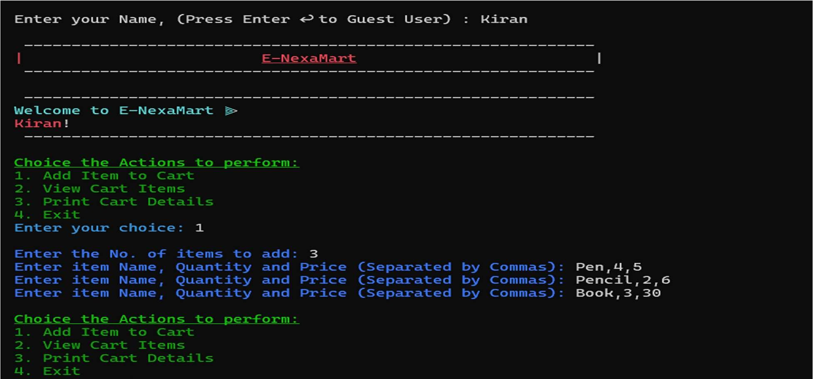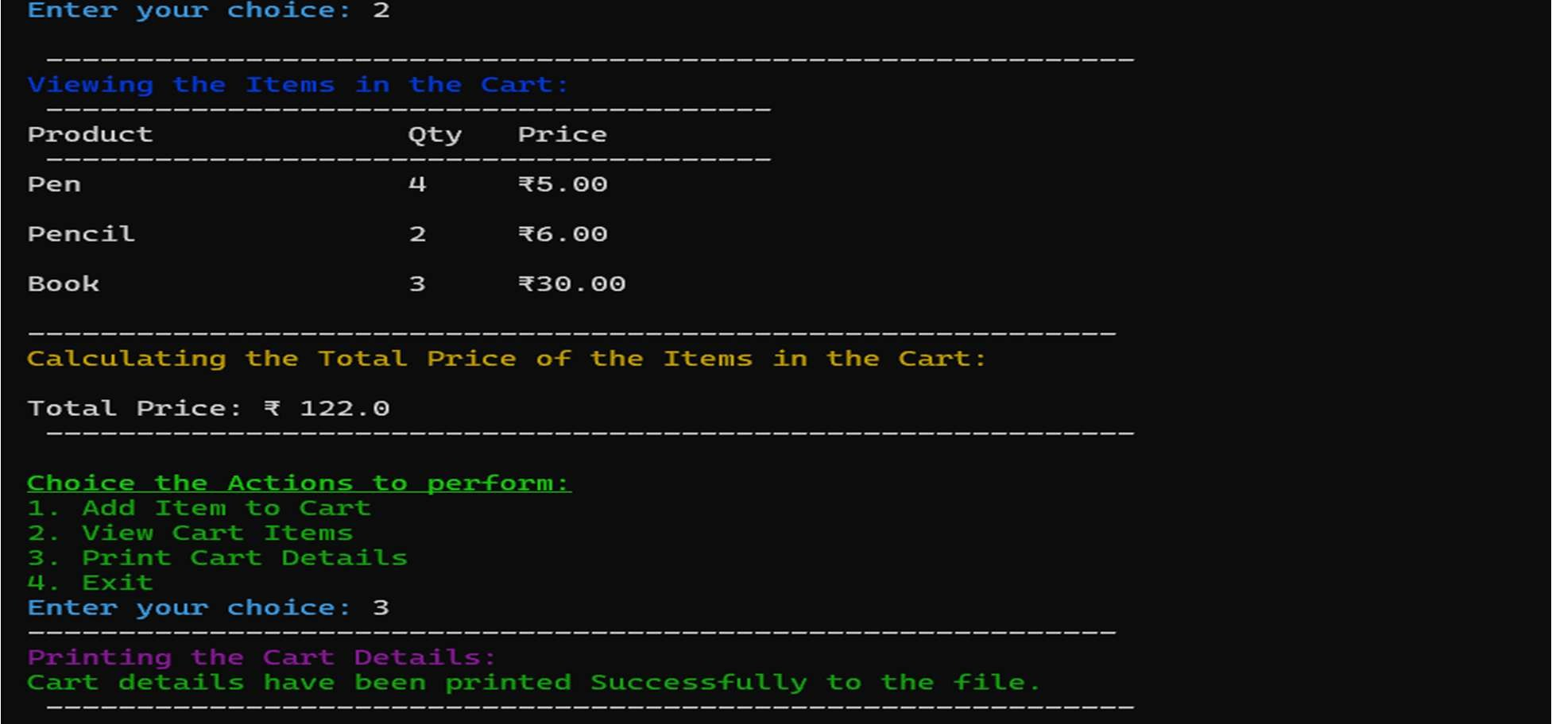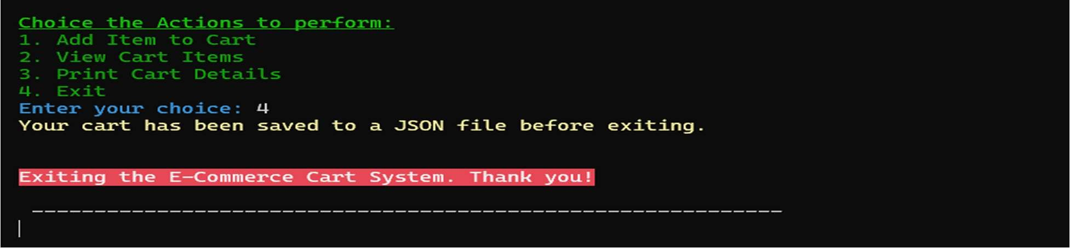
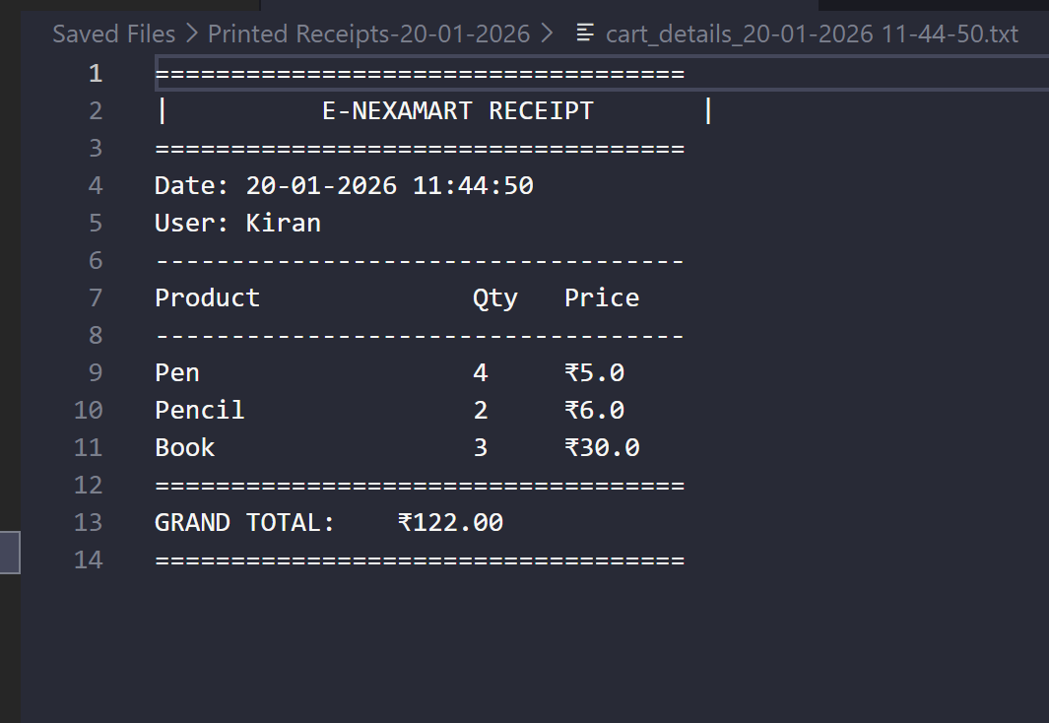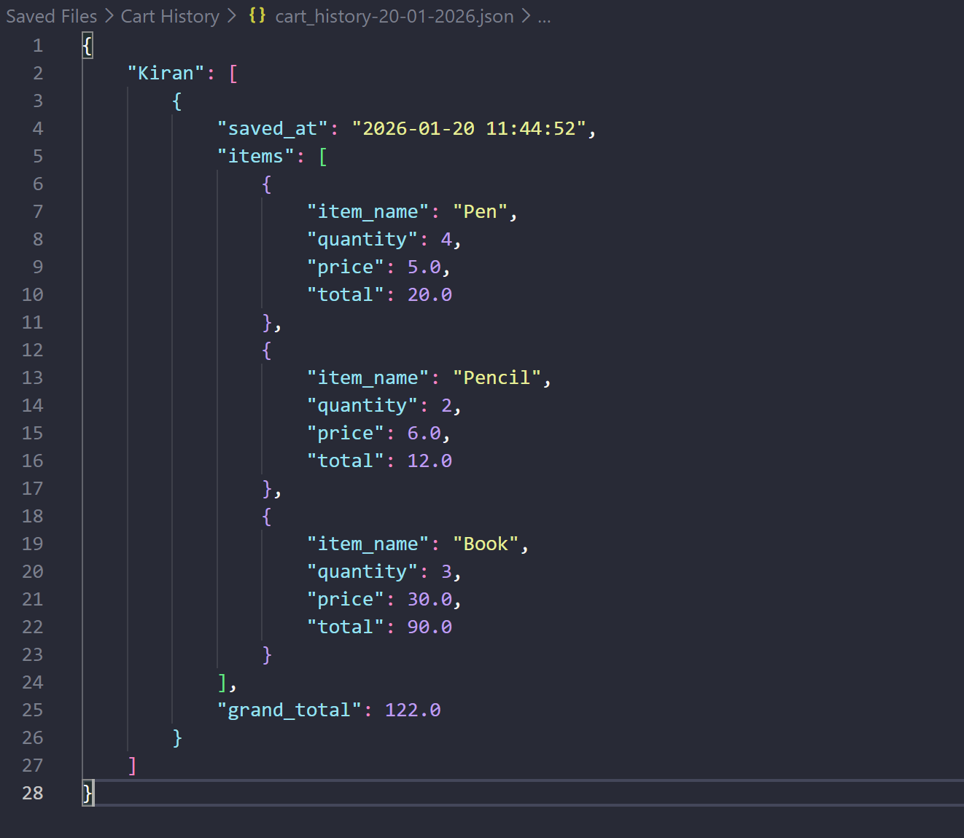

Files Structure and Flowchart :

